Book Metadata: An Introduction and
Worksheet
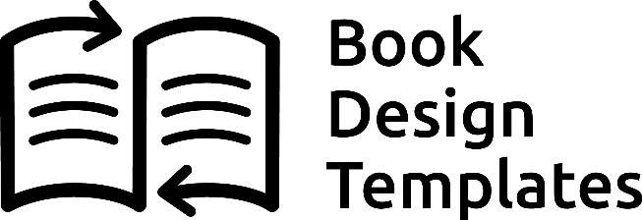
Metadata—even the word sounds hard to understand. meta comes from the Greek,
and means “above” or “enclosing” Metadata is simply data about data.
In other words, metadata is information about your data. You can think of data as being an electronic document, file, music file, book or any other form content pre- sented in electronic format. Metadata is meant to summarize the key characteristics of the underlying work—in our case, our books—for the purpose of making the work
itself discoverable to electronic searches.
Why Publishers Need to Know Keywords
Think about it for a moment. Suppose you want to know how to train your dog. You’d like a book that describes the step-by-step actions you can take to teach your dog to stop barking every time he hears a little sound in the bushes. You punch up Google
and look for a moment at the search bar. What are you going to type in?
This is the moment you need to understand when it comes to the book you’re trying to market online. There’s simply nothing as important as understanding what’s going through the mind of your potential book buyer when they are thinking of how to
search for the information they need.
1
The answer is: Metadata.
Let’s say there’s a really good dog training book that would answer this searcher’s question. Suppose the author has titled the book “Getting Along With Man’s Best Friend.” Notice that the words “dog” and “training” don’t appear in the title. How would Google or any other search engine know that this book could possibly be a great find
for the searcher?
Filling in All the Blanks
When this book was published the author (or publisher) had an opportunity to enter metadata about the book. The principle place this is done is in the Bowker information file about the book. Usually self-publishers fill this out when they buy their ISBNs and then forget about it.
That’s a mistake. This seemingly innocuous-looking form that appears to be just a nui-
sance to get through as fast as possible is actually a key to how well your book will sell. Why?
Metadata.
If you fail to fill in all the fields, or use the many types of metadata available, your book
will be harder to find. The information you’re providing is the same information that will come up in Google’s search. If the description of this book, for instance, says:
An easy to use, step by step guide to training your dog for behavior problems including
barking, biting and sitting.
It’s quite likely that the book will be included somewhere in Google’s results. Without this information, how would the search engine know that this book is a perfect fit for the searcher? It’s your responsibility as publisher to make sure the metadata for your
book is as accurate and complete as possible.
2

Title—Metadata forms usually don’t ask for a subtitle, so if it’s intrinsic to understand-
ing what the book is about, include it here separated from the title with a colon.
Publisher—Your publisher name. You can create your own imprint if you choose.
Publication Date—Original publication date for this edition. If a Pre-Order, Set
the date for the preorder to go live.
Organizing your Metadata
The worksheet at the end of this report has 15 categories of information you’ll need as you populate databases throughout the book industry with information about your book. You’ll do this by filling in forms when you upload files or fill out a submission for
for an online catalog or e-retailer.
Let’s run through the basic metadata items:
Contributors—You as the author are the main contributor but this also gives you a
chance to list co-authors, illustrators, or someone else who contributed content to the book.
ISBN— 13-digit versions
List Price—And sometimes the currency
Categories—This is crucial to get right, since you want your book to show up in searches for your main categories. Here’s a link to the Book Industry Study Group categories. However, some retailers have their own lists you have to select from, and you may be limited to only 2 categories, so pick them with an eye toward
people searching for your kind of book. https://bisg.org/page/BISACEdition
Format—Refers to paperback, hardcover, or some other format
3

WORKSHEET ON NEXT PAGE
Author Bio— A short bio of yourself.
Edition—If you revise more than 10% of the content, you can call it a second edition,
but keep in mind you’ll need a new ISBN to distinguish it from the previous ver- sion so they don’t get confused.
Keywords—Another critical field. You’ll mostly find this with online companies. For
instance, Amazon allows you 7 keywords on the Kindle information form, while Barnes & Noble allows 100 characters on the input form for Nook e-books.
Territory—This is usually tied to the currency you are selling in, but for English you can include the UK or EU on many forms, opening up your sales to English- speakers in other countries. It can also relate to the geographic areas you have rights to. Since you are a self-publisher, you own all rights unless you license them
to someone else.
Description—The third critical field. Having a chance to write your own copy that will be included in your book’s metadata is a powerful tool, so use it well. Amazon allows 400 words in the input for short descriptions. That’s a lot of words, and you should make sure that all your keywords, including your long-tail keywords that will be 2, 3 or 4 words long are included here. Hit every note, you’ll be glad you did.
Short Description—100 words. You will need this at some point, and it’s good to do it
at the same time, you do your long description.
4

Book Metadata Worksheet

Book Title:
Book Subtitle:
Contributors
Author:
Co-Author:
Other:
Edition: 1st
Publisher Name:
ISBN
Paperback:
eBook:
Hardcover:
Audiobook:
List Price
Paperback:
eBook:
Hardcover:
Audiobook:
Publication Date:
BISAC Category Code:
Primary:
Secondary:
Territory: Global
Keywords
1:
2:
3:
4:
5:
6:
7:

Short Description (100 Words Max):

Full Description (400 Words Max):

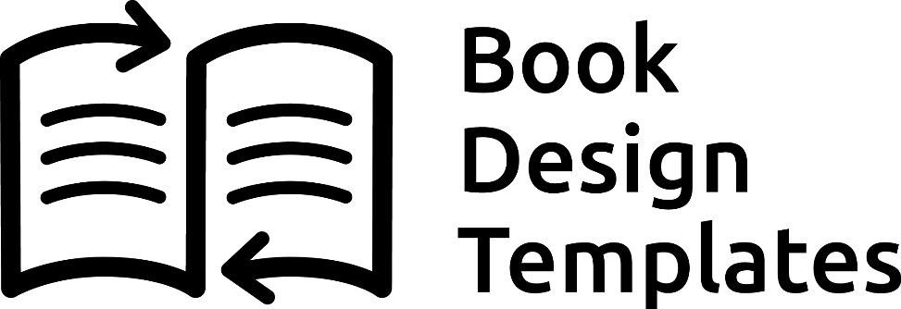

Beautiful Templates for Book Design Success

Now you can quickly and easily create beautiful books right in Microsoft Word, Apple Pages, Affinity Publisher, or Adobe InDesign. Built to industry-standard specifications, our pre-designed templates will make your book stand out, without all of those newbie mistakes. Handcrafted by an award-winning book designer, our exciting technology allows you to format your book for both print and eBooks at the same time, using a program you already own and know how to use, and without spending hundreds or thousands of dollars hiring a designer.

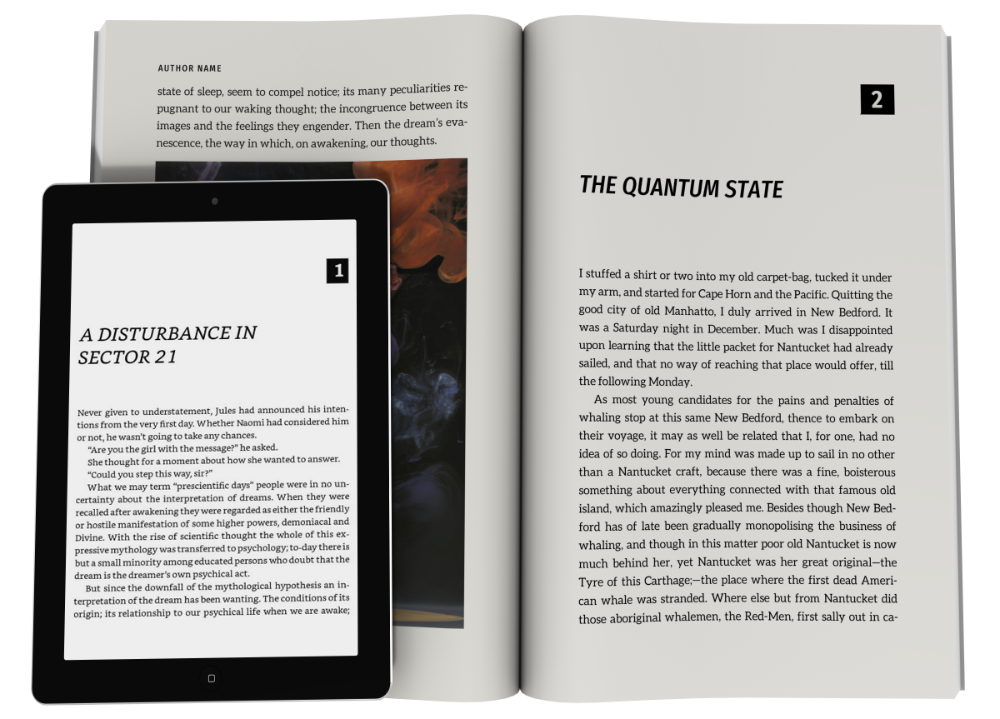

Shop all our Templates and Services Here
https://www.bookdesigntemplates.com/

